Case Study - Courseware Management System

System Functional Specifications
The Courseware Management System will be used to manage courses/classes for an organization that specializes in providing training. The organization offers a variety of courses in a variety of areas such as learning management techniques and understanding different software languages and technologies. Each course is made up of a set of topics. Tutors in the organization are assigned courses to teach according to the area that they specialize in and their availability. The organization publishes and maintains a calendar of the different courses and the assigned tutors every year. There is a group of course administrators in the organization who manage the courses including course content, assign courses to tutors, and define the course schedule. The training organization aims to use the Courseware Management System to get a better control and visibility to the management of courses as also to streamline the process of generating and managing the schedule of the different courses.

Use Case Diagram
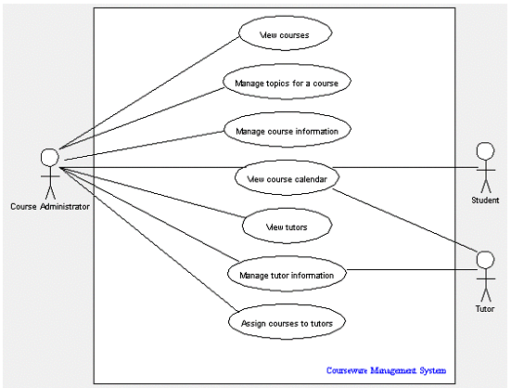

Class Diagrams

The class diagram of the Courseware Management System case study can be built after a careful analysis of the requirements. Previously, we identified the primary actors and use cases in the use case model of the case study. Because we did much of the groundwork of our analysis while building the use case model, we will use those analysis steps as the basis for identifying the classes and interfaces of this system.
Let’s recap the analysis that we had performed when we designed the use case model. The following terms and entities specific to the system were identified from the problem statement:
- Courses and Topics that make up a course
- Tutors who teach courses
- Course administrators who mange the assignment of the courses to tutors
- Calendar or Course Schedule is generated as a result of the
- Students who refer to the Course schedule or Calendar to decide which courses for which they wish to sign up
The potential actors of the system were:
- Tutors
- Course administrators
- Students
And the use cases of the system were:
- View courses
- Manage topics for a course
- Manage course information
- View course calendar
- View tutors
- Manage tutor information
- Assign courses to tutors

Identifying classes of the Courseware Management System
As we did in use case modeling, we will identify the classes and interfaces using an incremental approach.
- Identify the "active" entities in the system
The basic rule that we learned until now for identifying classes and interfaces is that classes and interfaces reflect important entities of the business domain of the system being modeled. We will apply this rule to determine classes and interfaces of the case study system. At first glance, the actors identified in the use case appear to be prime candidates for being listed as potential classes. Even though we had excluded Students and Tutors from our final list of actors, we will still include them in our list as potential classes. So, our first list of classes in the system appears to be:
  - Course administrators
  - Tutors
  - Students

- Identify business domain ("passive") entities in the system
But these are the "active" entities of the system. We had also identified "passive" elements in the system as well in the analysis for our use case model. These entities reflect the business domain and hence are potential classes for our system.
  - Courses
  - Topics that make up a course
  - Course calendar generated

Entities that reflect the business terms are also called business domain classes or just "domain classes." Some of the business domain classes hold transient data and some hold persistent data for the application. Normally, such business domain classes map to either one or many database tables.
For example, in our case study, the Course class can be modeled as a database table cms_course. The data in this table for a particular course will be represented by an instance of the Course class and made available to the rest of the application.

Relationships Between Classes
In a class diagram, obviously you can't have classes just floating around; you need to see the relationship between them. The following table shows the kinds of relationships between classes, their notation, and what they mean.
Sr. No. | Relation | Symbol | Description
1 | Association | 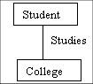 | When two classes are connected to each other in any way, an association relation is established. For example: A "student studies in a college" association can be shown as:
1 a. | Multiplicity | 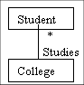 | An example of this kind of association is many students belonging to the same college. Hence, the relation shows a star sign near the student class (one to many, many to many, and so forth kind of relations).
1 b. | Directed Association | 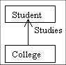 | Association between classes is bi-directional by default. You can define the flow of the association by using a directed association. The arrowhead identifies the container-contained relationship.
1 c. | Reflexive Association | No separate symbol. However, the relation will point back at the same class. | An example of this kind of relation is when a class has a variety of responsibilities. For example, an employee of a college can be a professor, a housekeeper, or an administrative assistant.
2 | Aggregation | 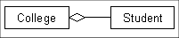 | When a class is formed as a collection of other classes, it is called an aggregation relationship between these classes. It is also called a "has a" relationship.
2 a. | Composition | 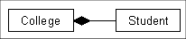 | Composition is a variation of the aggregation relationship. Composition connotes that a strong life cycle is associated between the classes.
3 | Inheritance/Generalization | 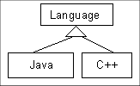 | Also called an "is a" relationship, because the child class is a type of the parent class. Generalization is the basic type of relationship used to define reusable elements in the class diagram. Literally, the child classes "inherit" the common functionality defined in the parent class.
4 | Realization | 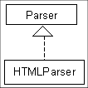 | In a realization relationship, one entity (normally an interface) defines a set of functionalities as a contract and the other entity (normally a class) "realizes" the contract by implementing the functionality defined in the contract.

Identifying relationships between the classes of the Courseware Management System
The next step after defining the classes of the Courseware Management System is to define the relationships and dependencies between these classes and interfaces. To define the relationships between the classes, we need to analyze the interconnections between the classes—whether implicit or explicit. Relationship analysis can be broken up into three steps:
- Identify relationships between "active" entities
Active entities normally share generalization relationships ("is-a"). Essentially, the common attributes and functionality between classes are defined in a common parent class. All the related child classes inherit functionality from the parent class. Apart from generalization, a few active entities can also be interconnected by a realization relationship. Recall that elements in a realization relationship implement declared functionality as a "contract." For example, a set of classes may implement functionality declared as methods in an interface, and this can be modeled as a realization relationship between the interface and the classes implementing the interface.
In our case study, we do not find an example of inheritance relationship between the active entities such as Student, Tutor, and CourseAdministrator or any realization relationships.
- Identify relationships between "passive" business entities
Passive business entities frequently share plain association or aggregation relationships ("has-a"). This is especially true because these business entities are non-transactional in nature and reflect data more than behavior. It is by far quite intuitive to identify aggregation as well as its variations—composition relationships for passive business entities.
Some of the classes in our case study do exhibit aggregation relationships. Because a set of topics makes up a course, we can define an aggregation relationship between the Course and Topic classes. Moreover, we can define this as a directed aggregation, meaning that you can check for the topics of a course but not vice versa. Similarly, we can define a plain association relationship between the Course and Tutor classes and Course and Student
- Analysis classes are of the following types as per their behavior, as shown in the following table:
Class | Behavior
Boundary | In an ideal multi tier system, the user interacts only with the boundary classes. For example, JSPs in a typical MVC architecture form the boundary classes.
Control | These classes typically don't contain any business functionality. However, their main task is to transfer control to the appropriate business logic class, depending on a few inputs received from the boundary classes.
Entity | These classes are those that contain the business functionality. Any interactions with back-end systems are generally done through these classes.

ClassName | Methods
Course | viewAllCourses()  viewCourseInformation()  createCourse()  modifyCourse()  removeCourse()
Topic | viewAllTopics()  viewTopicInformation()  createTopic()  modifyTopic()  removeTopic()
Tutor | viewTutorInformation()  createTutor()  modifyTutor()  removeTutor()
CourseCalendar | viewCourseCalendar()
Student | viewAllStudents()  viewStudentInformation()

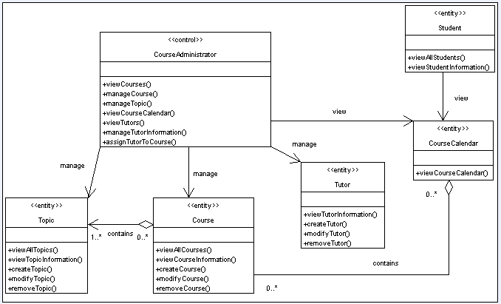

Object Diagrams in UML
A class diagram is a static representation of your system. It shows the types of classes, and how these classes are linked to each other. In this edition of our series we introduce the object diagram.
Although we design and define classes, in a live application classes are not directly used, but instances or objects of these classes are used for executing the business logic. A pictorial representation of the relationships between these instantiated classes at any point of time (called objects) is called an "Object diagram." It looks very similar to a class diagram, and uses the similar notations to denote relationships.
If an object diagram and a class diagram look so similar, what is an object diagram actually used for? Well, if you looked at a class diagram, you would not get the picture of how these classes interact with each other at runtime, and in the actual system, how the objects created at runtime are related to the classes. An object diagram shows this relation between the instantiated classes and the defined class, and the relation between these objects, in the logical view of the system. These are very useful to explain smaller portions of your system, when your system class diagram is very complex, and also sometimes recursive.

http://www.developer.com/design/article.php/2206791

